Draft 3

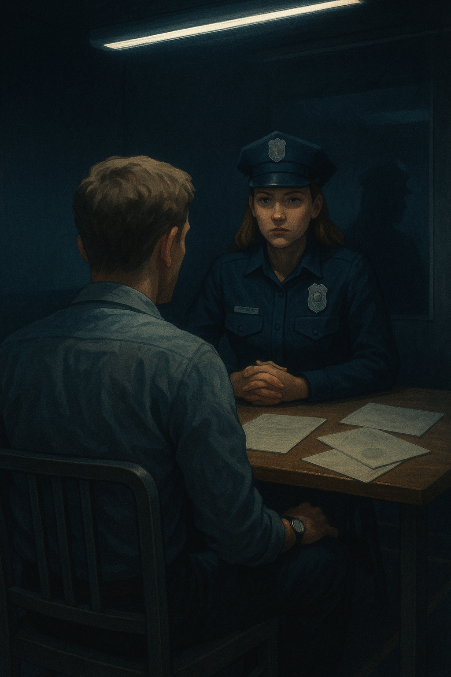

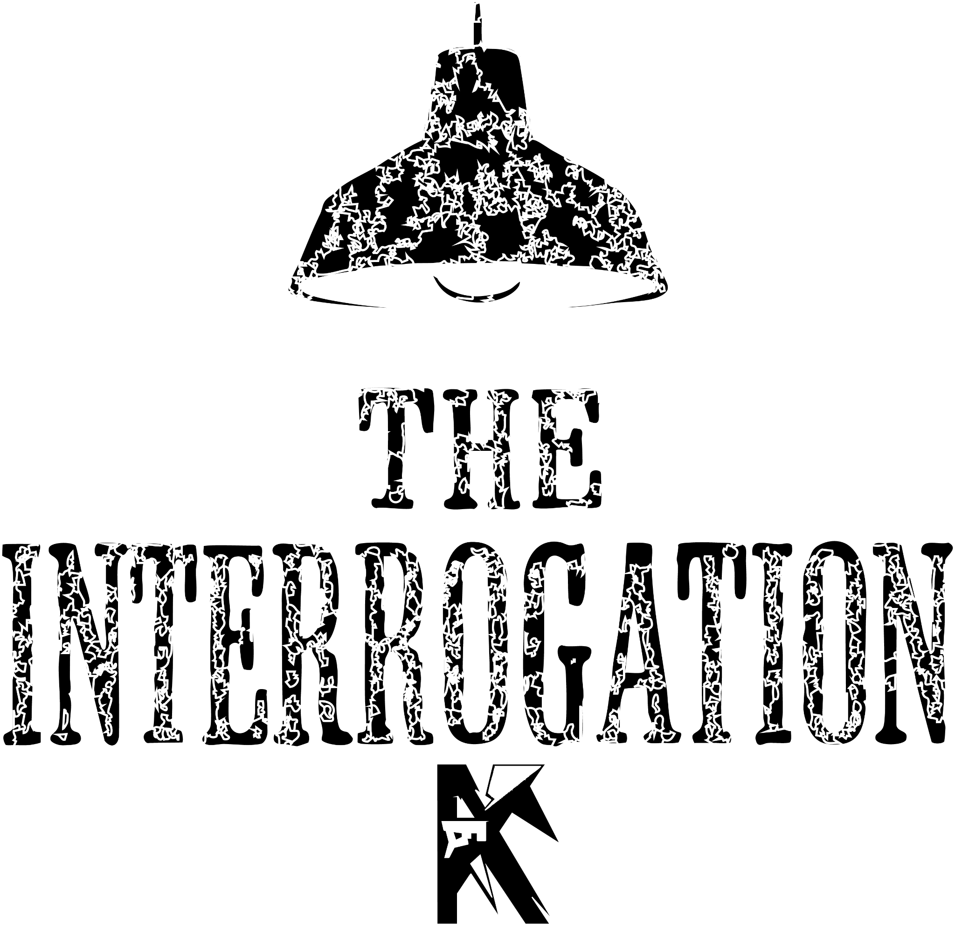

By Kyle Young

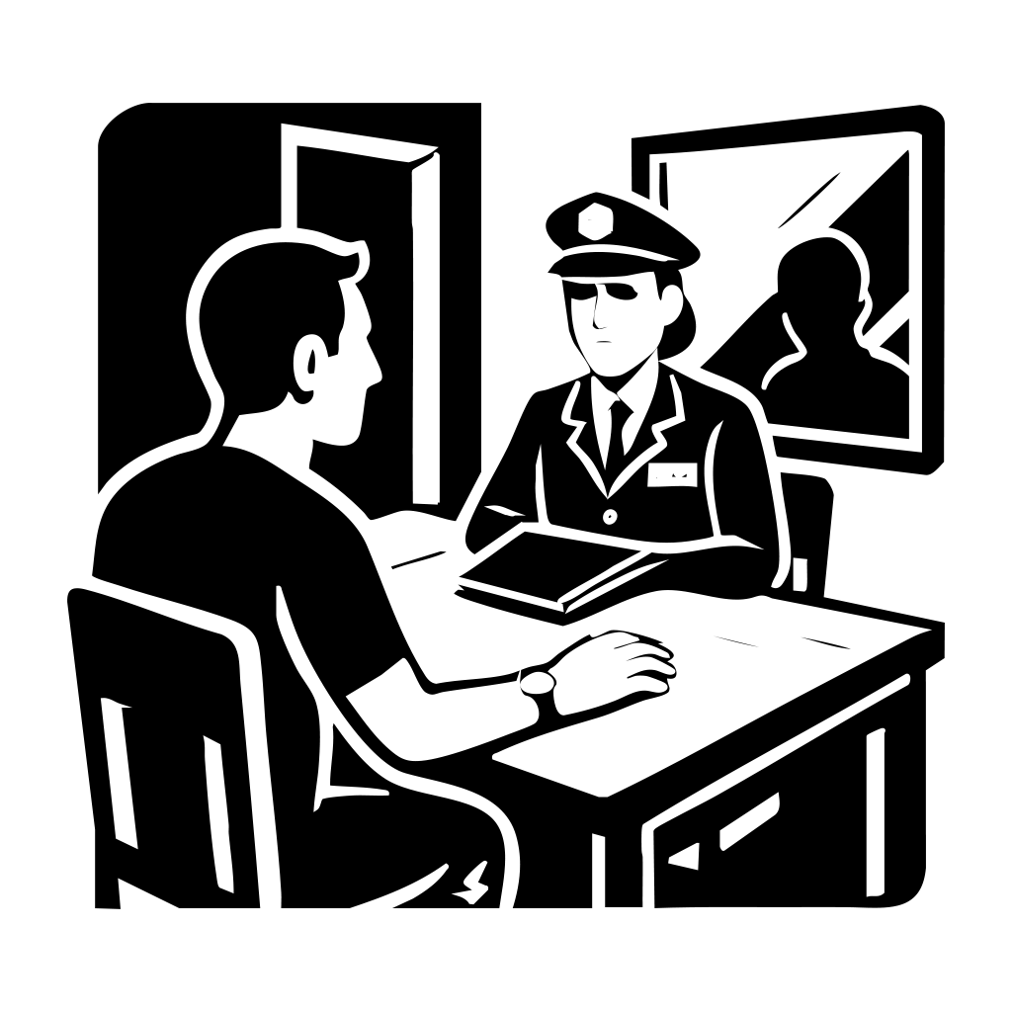

The Silent Hello
The mirror stares back at me, cold and silent. My hand, inexplicably, is stuck to the wooden table. It’s the kind of table I remember from high school—uncomfortable, splintered, too small for grown hands. And somehow, the chair beneath me is the exact same. I shift, but it offers no relief. I look up to see nothing but darkness.
Across from me, an empty chair waits. It’s not just empty—it feels... aware. Like it’s watching me. Judging. Tearing me apart molecule by molecule, without a single word spoken.
My wrist itches. I glance down. My watch ticks, impossibly slow—each second stretching longer than it should. A giant mirror looms to my right, and something about it gnaws at me. It's double-sided. I know it. I feel it. Someone is behind it, watching.
But I don’t know who. Or why.
The door creaks open, and a woman steps inside. Her dark blue police uniform is crisp, hat angled with care, the name tag “Lois." She doesn’t smile as she sits across from me. Her file lands on the table with a quiet thud. My leg begins to tap involuntarily. Her gaze pierces through me.


The Cop
She speaks first.
“Do you know why you’re here?”
I meet her eyes. They're searching, dissecting. I respond, dryly:
“I was hoping you knew.”
She removes her hat, sets it beside the file, and opens it. As she flips through the pages, photographs spill across the table—grainy shots of me and women. Dinners. Sidewalk strolls. Drops at front doors.
“What is this?” I mutter.
“You tell me,” she replies, coolly.
I scoff.
“Surveillance? You’ve been following my dating life now?”
She leans back, folds her arms.
“So you agree these are photos of you.”
I lean forward. The images blur, the faces pixelated—but I know I’m in them. The edges of my confidence begin to fray.
“What’s this about?” I ask.
Her tone sharpens.
“You tell me. These women—you were the last person seen with all of them.”
A chill runs through the room. The air tightens. Something shifts.
“You think that means I did something to them?”
She doesn’t blink.
“I can see it in your eyes. You know something.”
I glance again at the photos. The angles—they’re from far off, like from inside a car. Someone watching.
“I met them all on an app,” I murmur.
“Why would I hurt them?”
Suddenly, her hands slam the desk. I flinch.
“Because you're lying!” she snaps.
“Everything points to you!”
I ignore her. I pull the photos closer. Something is off. The light. The framing. The intent.
Then I ask, coldly:
“Who took these pictures?”
She hesitates. Her face stiffens.
“What do you think this is?” she says, scooping up papers and slamming them down again.
The sheets scatter.
They're blank.
No reports. No case numbers. No evidence.
Just paper.

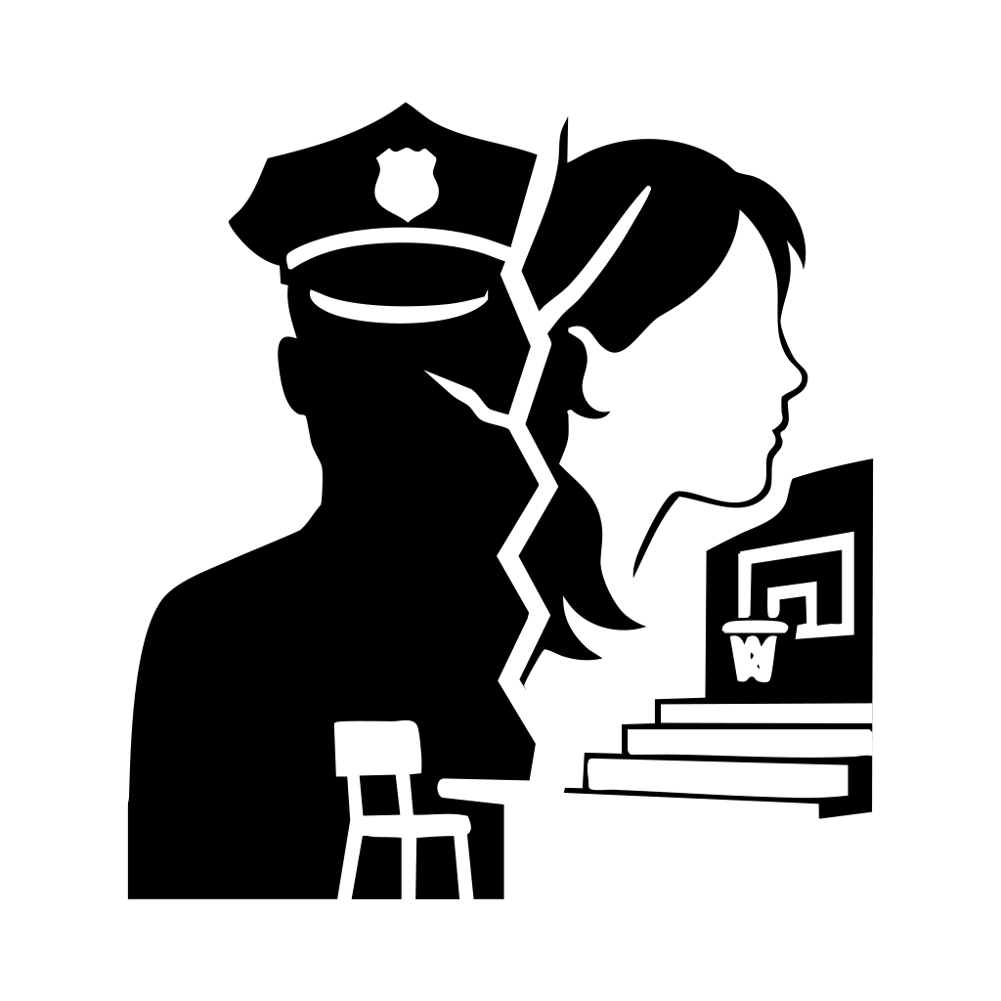

The Lies
I watch her unravel. Her tough facade buckles, her shoulders slump. And then—tears. Slow, deliberate.
I ask again, softly this time:
“Who took the pictures?”
She chokes on her words.
“I did.”
The room goes still.
As I look back at the mirror to see it shift.
I stand to push it, the room around shifts, moves, like it was made out paper, falls around us,
Revealing my high school’s gym.
Then, it hits me. Her face, younger. Glasses. A timid girl in the back of my high school science class. Always staring, always silent. The memory detonates in my mind.
“I remember you,” I say.
“We had class together. You... you never spoke to me.”
She nods slowly.
“I was protecting you.”
“Protecting me? From what?”
Her voice becomes honeyed, delusional.
“From them. They were pulling you away. You belonged to me. You just didn’t realise it yet.”
My feet are heavy, as I slowly walk away from her.
“How are we in the high school?”
Then, a terrifying smile took over her face
“A few years after we left high school, there was a series of murders. I made it so it would just be you and me, back in the place where we fell in love.”
Then it hit me, her name wasn’t Lois, it was Hannah, how did she get the police officer outfit, badge, gun. I hit the gym wall.
“I don’t even remember coming here,” I whisper.
She walks closer. Calm now. Terrifyingly calm.
“That’s because you didn’t.”
I reach for the gym door handle. It doesn't budge.
Locked.
Her hand moves—from her taser to her gun.
“Did you kill them?” I ask, my voice barely my own.
She smiles. Eyes gleaming.
“They were distractions. I took them off the board.”
My pulse pounds. She's reaching for her weapon. Time fractures.
I charge.
A single shot shatters the silence.
Then, only ringing.
Then... nothing.

Draft 2
The mirror stares back at me, cold and silent. My hand, inexplicably, is stuck to the wooden table. It’s the kind of table I remember from high school—uncomfortable, splintered, too small for grown hands. And somehow, the chair beneath me is the exact same. I shift, but it offers no relief.
Across from me, an empty chair waits. It’s not just empty—it feels... aware. Like it’s watching me. Judging. Tearing me apart molecule by molecule, without a single word spoken.
My wrist itches. I glance down. My watch ticks, impossibly slow—each second stretching longer than it should. A giant mirror looms to my right, and something about it gnaws at me. It's double-sided. I know it. I feel it. Someone is behind it, watching.
But I don’t know who. Or why.
The door creaks open, and a woman steps inside. Her dark blue police uniform is crisp, hat angled with care. She doesn’t smile as she sits across from me. Her file lands on the table with a quiet thud. My leg begins to tap involuntarily. Her gaze pierces through me.
She speaks first.
“Do you know why you’re here?”
I meet her eyes. They're searching, dissecting. I respond, dryly:
“I was hoping you knew.”
She removes her hat, sets it beside the file, and opens it. As she flips through the pages, photographs spill across the table—grainy shots of me and women. Dinners. Sidewalk strolls. Drops at front doors.
“What is this?” I mutter.
“You tell me,” she replies, coolly.
I scoff.
“Surveillance? You’ve been following my dating life now?”
She leans back, folds her arms.
“So you agree these are photos of you.”
I lean forward. The images blur, the faces pixelated—but I know I’m in them. The edges of my confidence begin to fray.
“What’s this about?” I ask.
Her tone sharpens.
“You tell me. These women—you were the last person seen with all of them.”
A chill runs through the room. The air tightens. Something shifts.
“You think that means I did something to them?”
She doesn’t blink.
“I can see it in your eyes. You know something.”
I glance again at the photos. The angles—they’re from far off, like from inside a car. Someone watching.
“I met them all on an app,” I murmur.
“Why would I hurt them?”
Suddenly, her hands slam the desk. I flinch.
“Because you're lying!” she snaps.
“Everything points to you!”
I ignore her. I pull the photos closer. Something is off. The light. The framing. The intent.
Then I ask, coldly:
“Who took these pictures?”
She hesitates. Her face stiffens.
“What do you think this is?” she says, scooping up papers and slamming them down again.
The sheets scatter.
They're blank.
No reports. No case numbers. No evidence.
Just paper.
I watch her unravel. Her tough facade buckles, her shoulders slump. And then—tears. Slow, deliberate.
I ask again, softly this time:
“Who took the pictures?”
She chokes on her words.
“I did.”
The room goes still.
Then, it hits me. Her face, younger. Glasses. A timid girl in the back of my high school science class. Always staring, always silent. The memory detonates in my mind.
“I remember you,” I say.
“We had class together. You... you never spoke to me.”
She nods slowly.
“I was protecting you.”
“Protecting me? From what?”
Her voice becomes honeyed, delusional.
“From them. They were pulling you away. You belonged to me. You just didn’t realize it yet.”
I stand. My feet are heavy, but I walk toward the door.
“I don’t even remember coming here,” I whisper.
She stands too. Calm now. Terrifyingly calm.
“That’s because you didn’t.”
I reach for the door handle. It doesn't budge.
Locked.
Her hand moves—from her taser to her gun.
“Did you kill them?” I ask, my voice barely my own.
She smiles. Eyes gleaming.
“They were distractions. I took them off the board.”
My pulse pounds. She's reaching for her weapon. Time fractures.
I charge.
A single shot shatters the silence.
Then, only ringing.
Then... nothing.

Draft 1
As I look at the mirror reflecting at me as my hand gets stuck to the wooden table and my sit looks like one I had back in high school, and it wasn’t confiable back then and its still not now, Then I see a anonymous chair sitting on the other side of the table as it steering at me, feeling like its ripping me apart more and more without saying a word as I look down at my wirst to see my watch slowly tick the minte away, As I giant mirror looks on me for the side I couldn’t but think that its double sides as I feel someone watching me, but I don’t know who, or why but then the door opens as a woman holding paper wearing her dark blue police uniform with her hat on, as she sits down in front of me, as I can’t help but to see my leg start to tap, then the woman looks at me and asks, “So why do you think your here?” Then my eyes wonder to her eyes as she searches into my and I says, “Well I hope you would know.” Then the woman puts her hat onto the table as she opens up the file she walked in as she flips threw the paper work to see pictures of me with some girl as he leads in looking closer as I says, “Some picture of me dropping off dates, its nice to know you know how to spy on people” then the woman leans back in her chair as she says, “So you agree this are picture of you.” Then I leaned in closer to see a blurring pixelated image as my confidence started to waver as I started to read her face because I knew I was in those photo but she trying to ament to something that I didn’t do, so asked, “Whats it to you?” then the woman sits back in her chair with a anynd look on her face as she put her hand on her taser as she says, “well that sound like your trying to hide something.” then I lean in with a smile on my face and says, “If I was trying to hide something you think I would be sitting here with you, looking a cop right in their as they question me about my own life.” With the look on the woman face changing it like she jumped into a new mode as the playing new act was over and her posture changed then her shakily voice now turns confident as she accuses me saying, “These woman where last seen in these picture with you.” then I sit back feeling the atmosphere in the room change from anxiety to attacked as I says, “So you can find these woman, doesn't mean I had anything to do with it.” as I looked at the one of the picture again as the woman stands up and says, “You know something, I can read it in your eyes.” then I start looking at another picture as I says, “These woman I all meant on a dating app, Why would I kill them?” then the woman slams her hands on the desk as I jump back in the sit as she leads closer as she says, “Stop lying to me, all the evidence is pointing to you!” then I ignore her as I move the pictures closer to me see all of them, picture taken from a distance looking like they where take in a car, like someone was watching me on these dates, then I looked up at the woman and says. “What is all this evidence?” Then the woman picks up all the papers from the files and says, “what do you think this is.” then She throws the paper onto the table as the pile slides apart revealing the pages are empty as I watched her confidence turned into anrgyer as I see her towning body above slowly deflating as she slowly sits back down in her sit, then I ask, “Who took these photos?” as I shit them around towards her she looks at them as tears start to fall from her eye she whimpers, “I did.” then with that look on her face it final click in his mind as I says, “I remember you, where do I remember you from?” then the girl look up at me as it final clicked in my mind all the way back in high school as I can see her face 10 years ago as we shared the same science class but then her voice cuts through my thoughts as she says, “I’m just protecting you.” I then look at her confused as I ask, “protecting me from what?” then her pretty eyes try to convince me that what she about to say is normal as she says, “I was protecting you from all of them, you where always my, you just never realised it yet.” as I stand up I slow walk towards the door as I says, “When I think about, I don't remember coming here.” then she slowly stands up looking a me as I try to open the door to hear that its locked as she says, “Now you can be mine forever.” as she moves her hand from her taser to her gun as I asks, “So all those woman, did you kill them.” as he hand wraps around the gun trigger as she smile as she says, “They where distracting you from me, So I took them off the board.” as I could feel my heart beating out of my chest I can see she ready to pull her gun out, So I charge, as the gun fire rings in my ears as the pain begin to stop

